**Ex:** 1

**Date:** 10/10/2020

**Aim:**

To Create a python program to print the calendar of given year and month.

**Program:**

import calendar as c

yr=int(input())

mn=int(input())

if(yr>999 and yr<2030):

if(mn>=1 and mn<=12):

print(c.month(yr,mn))

else:

print("Invalid Input")

else:

print("Invalid Input")

**Output:**

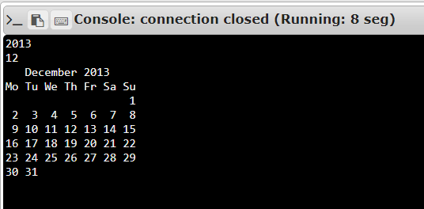

**Result:**

Thus generating calendar of given year and month is done and output of the program is obtained.

**Link:**

<http://103.53.53.18/mod/vpl/forms/submissionview.php?id=229&userid=1652>